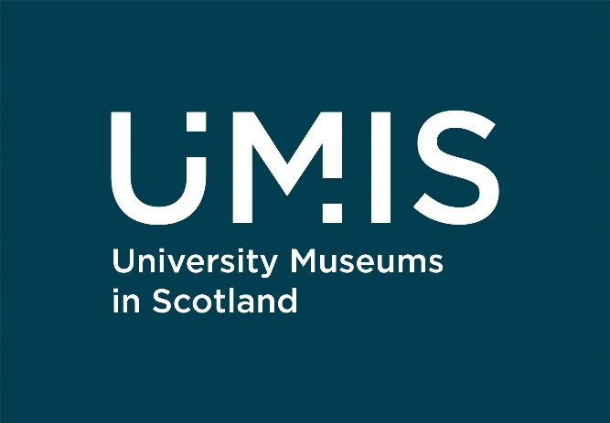

Our work: Decolonisation and Repatriation

The Hunterian, University of Glasgow: Curating Discomfort

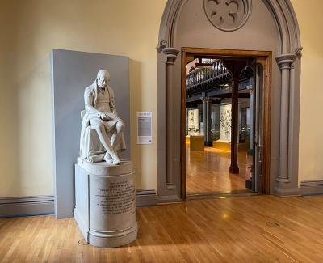
The project looked at new ways to explore the interpretation of contested collections and to design and deliver a series of museum interventions that takes the museum out of the institutional comfort zone and embeds this work within the museum’s practice.
Their new project ‘Power in this Place: Unfinished Conversations’ builds on this work, engaging with communities across the collections and reinforcing anti-racist, participatory approaches, reflection, and debate.
Find out more: https://bit.ly/CuratingDiscomfort (this link will take you to The Hunterian’s website)

University of Aberdeen: Repatriation of Benin Bronze

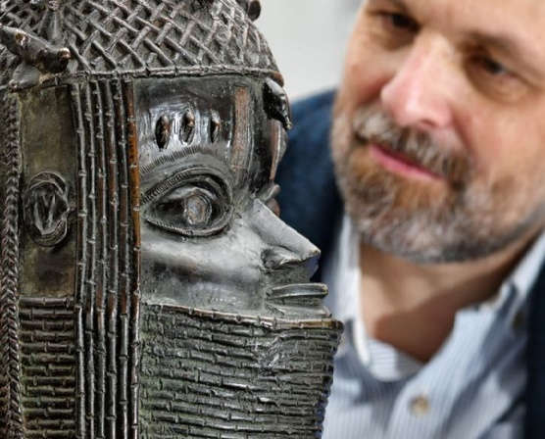
In 2021, the University of Aberdeen's Museums and Special Collections developed a repatriation pathway with partners in a Nigeria. This saw the return in October 2021 of a Benin Bronze to the Nigerian National Commission on Museums and Monuments and the Court of the Oba of Benin. The University’s procedure and criteria were first developed in 2002 to enable the return of a sacred bundle to the Kainai First Nation in Canada, with the criteria now being used as a model for museums internationally.
View the repatriation ceremony: https://bit.ly/UoABenin (this link will take you to YouTube)

University of St Andrews: Re-collecting Empire

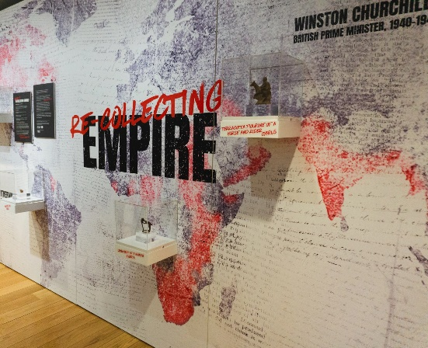
The Museums of the University of St Andrews Re-collecting Empire project explores present-day entanglements of cultures resulting from colonial encounters in the past, and how creative responses can add new dimensions to heritage objects through examining and re-telling their narratives with a diverse set of audiences. The project is a key part of the University’s strategic objective to tackle institutional legacies and work for a more inclusive and equitable future.
Find out more: https://bit.ly/recollectingempire (this link will take you to the Museums of the University of St Andrews website)

University of Dundee: Decolonising D’Arcy Thompson
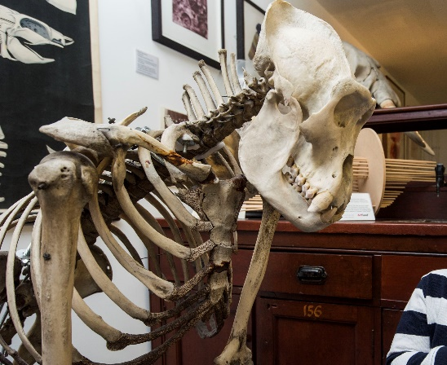
The collections of the D’Arcy Thompson Zoology Museum were largely acquired during the colonial era. As part of their commitment to inclusion and revealing forgotten aspects of the past, the University of Dundee Museums are currently working on a project to decolonise the Museum, researching the stories behind their specimens to find new ways to interpret them.
Find out more: https://bit.ly/decolonisingdarcythompson (this link will take you to the University of Dundee Museums website)

