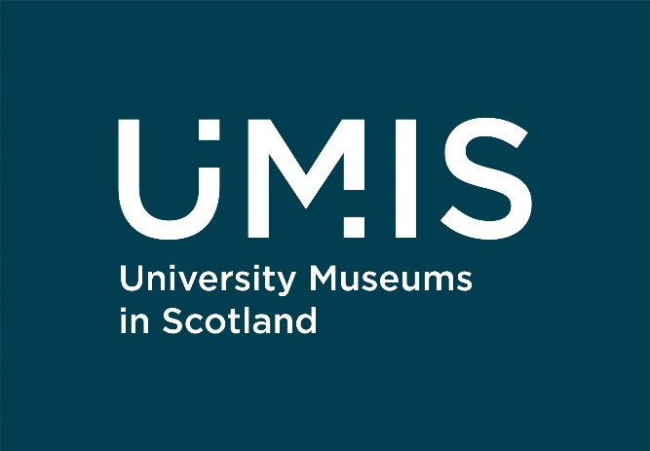

Our work: Equity, Diversity & Inclusion

Young Artivists: A Silver and Gold Arts Award project
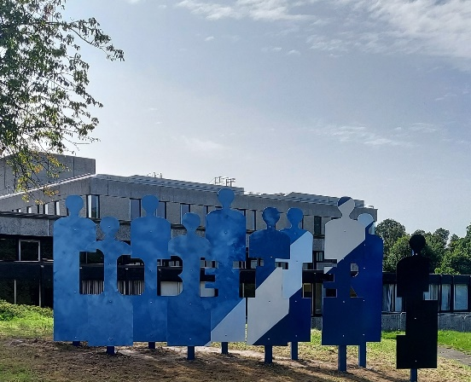
Artivism is the act of combining art with activism. This project – a partnership between the University of Edinburgh Collections and the University of Stirling Art Collection - worked with young people (aged 11-18) from across Scotland who are traditionally under-represented at university. It aimed to develop participants’ artistic knowledge and skills and apply them to discuss issues that they care about. The programme included arts event attendance, work experience with arts organisations and events organisation and participants were supported by student mentors.
Find out more: https://bit.ly/YoungArtivists (this link will take you to the Young Artivists page on the University of Edinburgh website)

University of Stirling: Second Chancers

This University’s Art Collection, in partnership with Community Justice Scotland, worked with those with experience of the Community Justice system (where people who commit certain crimes receive community-based sentences). In addition, the Art Collection developed activities to complement teaching, inserting humanity into considerations of justice, provided Trauma Informed Practice Training for creative practitioners in the area, and is exploring ways to support routes into Higher Education for those with criminal records.
Find out more: https://bit.ly/SecondChancersUoS (this link will take you to the University of Stirling Art Collection website)

University of St Andrews: Moving Art, Connecting Voices

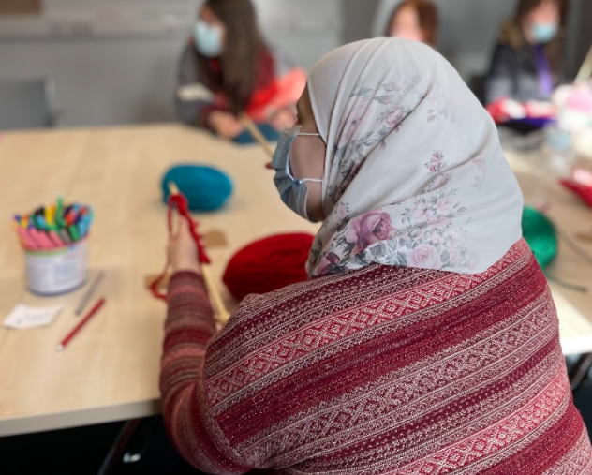
‘Moving Art, Connecting Voices’ brings together young people from Afghanistan, Kurdistan, Syria, and Vietnam who have recently moved to Scotland and unites them with pupils from Levenmouth Academy in Fife. The group create art, poetry, and music to explore their identity and cultures and tackle the media’s portrayal of “migrants” as a faceless whole. The project is part of the wider Re:Collecting Empire project, designed to identify missing stories within their collections.
Find out more: https://bit.ly/MovingArtConnectingVoices (this link will take you to the Museums of the University of St Andrews website)

Robert Gordon University: Digital Tapestry
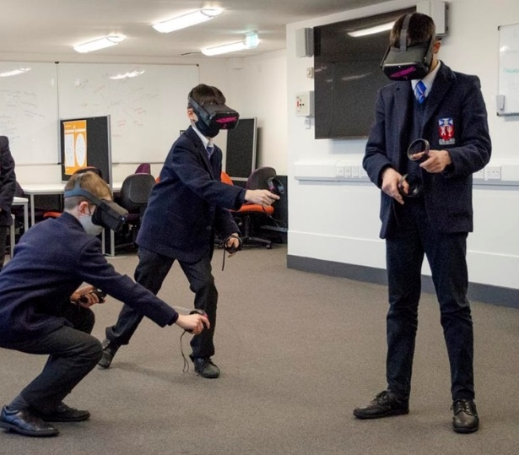
RGU Art & Heritage (as part of the University’s Library Service) worked in partnership with the Mobile Art School – a community outreach project aimed at engaging and connecting schools across Aberdeen and beyond. The project worked with schools and community groups who were particularly impacted by lockdown to create digital ways for audiences to explore their collections remotely, including the use of VR and AR technology.
Find out more: https://bit.ly/DigitalTapestry (this link will take you to a site containing the resources from the Digital Tapestry project)

