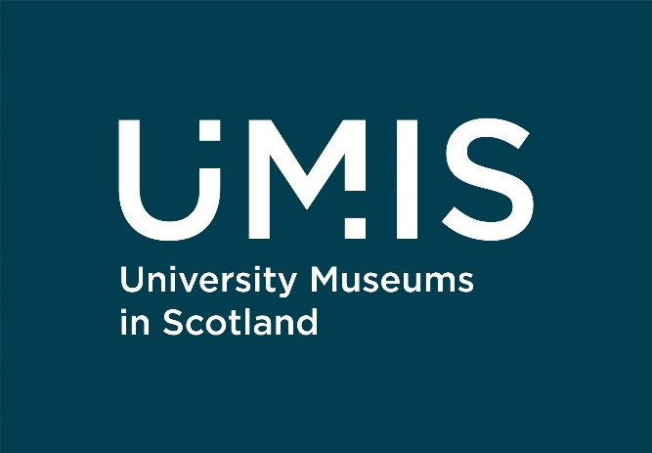

Our work: Environment

University of St Andrews: Dive In!
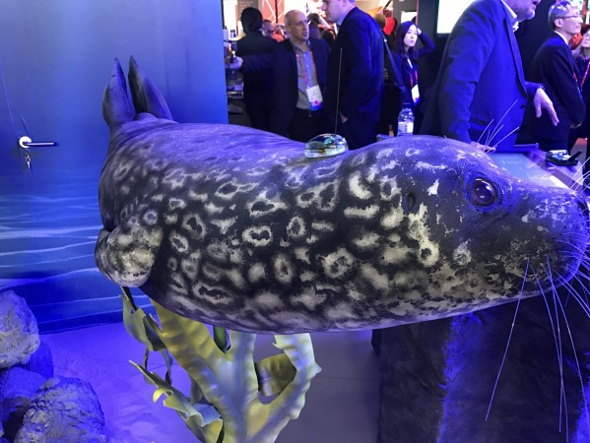
The Dive In! Protecting our Oceans exhibition and associated programming explored the ocean and the threats its facing. Held at The Wardlaw Museum, the exhibition prompted visitors to consider how their actions impact what happens in the ocean and looked at how museums can have a positive impact on our environment by encouraging people to make sustainable decisions. The museums worked with a consultant in environmental behaviour change and an evaluation consultant to carefully research what effect visiting the exhibition had on audiences.
Find out more: https://bit.ly/DiveInWardlaw (this link will take you to the Museums of the University of St Andrews website)

The Glasgow School of Art: Environmental Sustainability
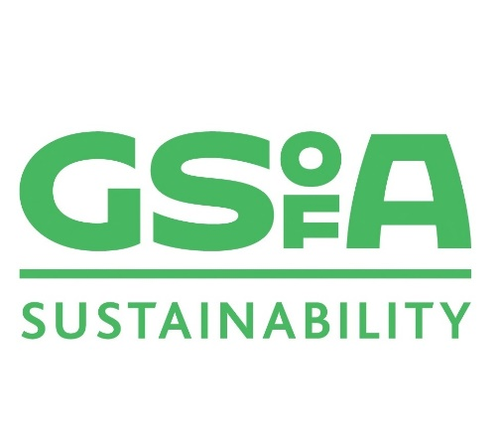
The team worked with GSA Exhibitions, Central Saint Martins and the Women’s Library on two events looking at ‘Climate Emergency and Creative Action’ and ‘Collecting the Climate Emergency: Process and Practice’ as part of the Close of Play series, to complement COP26.
They have also explored the concept of ‘digital loans’ considering how augmented reality could be used as an alternative method of borrowing physical objects and have environmental benefits.
Find out more: https://bit.ly/GSAsustainability (this link will take you to the Glasgow School of Art Sustainability website)

University of Glasgow: Changing Climate, Changing Stories
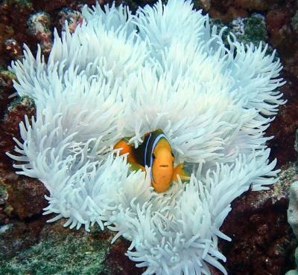
The Hunterian’s Changing Climate, Changing Stories interventions were launched for COP26. Working with researchers from the University’s Institute of Biodiversity, Animal Health and Comparative Medicine, the project looked at the museum’s objects from an environmental and sustainability perspective. In addition, they ran events for families, online talks, and social and academic events throughout the year looking at sea science and biodiversity.
Find out more: https://bit.ly/ChangingClimateStories (this link will take you to The Hunterian’s website)

University of Stirling: Space & Place
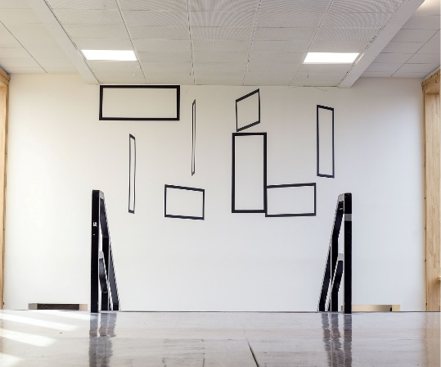
The Art Collection supports the University’s Strategic Vision to create ‘Research with Impact’ and has a regular programme of events and public engagement activities which support their academic community to engage with and communicate research which has a positive impact on wider society.
The 2022/23 exhibition programme is Space & Place looking at responses to the natural and built environment.
Find out more: https://bit.ly/SpacePlaceStirling (this link will take you to the University of Stirling Art Collection’s web pages)

