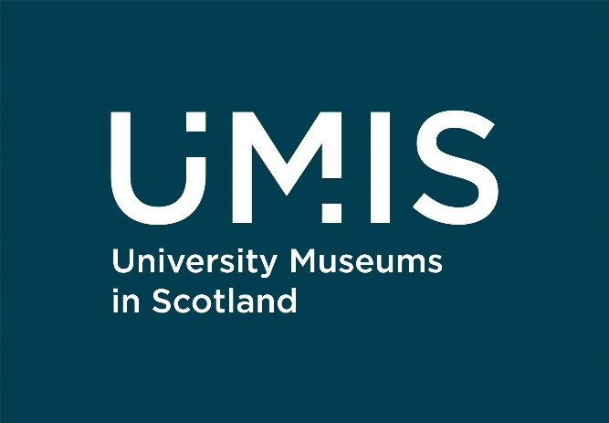

Our work: Health & Wellbeing

University of Edinburgh: Prescribe Culture
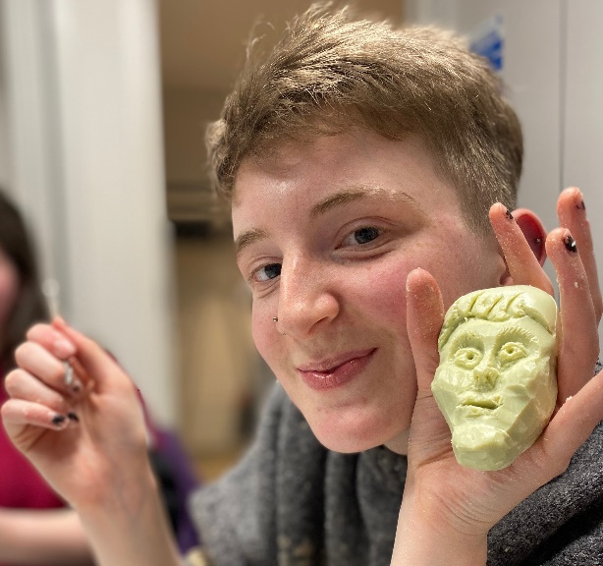
This sector-leading social prescription programme involves both guided sessions for students referred via Student Services, and self-led participation for broader audiences at a variety of venues both online and offline. The programme now offers programming for those living with dementia and is the foundation of a UKRI funded research project ‘Prescribe Culture Highland’, in collaboration with the University of the Highlands and Islands, exploring the feasibility of scaling up cultural and natural assets for the benefits of public health.
Find out more: https://bit.ly/UoEPrescribeCulture (this link will take you to the University of Edinburgh website)

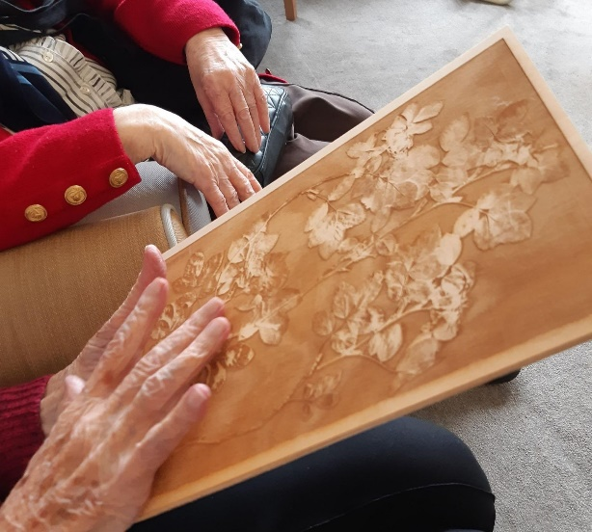
University of Dundee: Sensory Backpacks

The Museum Engagement team has created a sensory backpack for use in reminiscence sessions in care homes and community centres in the local area. Featuring 3D models, laser-etched replicas of Herbarium specimens, soft sculptures, scent bottles and textured paint samples it allows members of the public who aren’t able to visit the University to experience and engage with the collections remotely. The backpack has proved highly effective in stimulating memories and emotions of those using it.

Find out more: https://bit.ly/UoDSensoryBackpack

University of Stirling: Wellbeing Programming
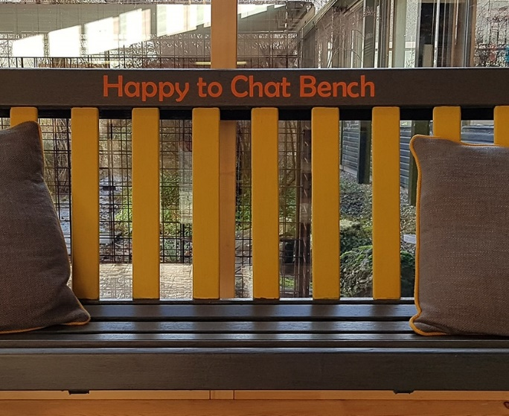
The Art Collection at the University of Stirling has introduced a wellbeing programme in conjunction with Student Support Services. They offer a range of activities for students and the public, either online or in-person, including forest bathing sessions, filmed dance performances, gardening, a ‘happy to chat’ bench and through their sculpture collection which is displayed throughout the campus.
Find out more: https://bit.ly/UoSWellbeing (this link will take you to the University of Stirling Art Collection’s website)

University of St Andrews: Online Wellbeing

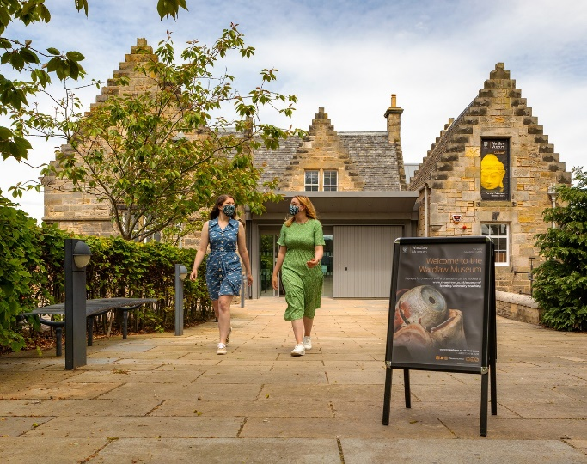
During Covid, the museums developed online wellbeing resources, designing and badging each of the events with at least one of the Five Ways to Wellbeing – Connect, Learn, Be Active, Take Notice, and Give. By promoting the programmes alongside the Five Ways to Wellbeing, audiences knew how each event can contribute to their wellbeing. Some of the resources have now been developed into an online mindfulness resource booklet and they have launched a Cultural Prescription offer.
Find out more: https://bit.ly/UofStAWellbeing (this will take you to the Museums of the University of St Andrews web pages)

